# Log VSWR Bridge

Kjell has designed a high power VSWR bridge which could be connected to an Arduino to implement a VSWR meter with electronic display. This could be an Arduino Nano Every with Nextion display.

# Hardware

Two analogue inputs for forward and reverse power. Suggest A0=forward, A1=rev. There is nothing more needed – a simple prototype board is all that’s needed.

The analogue inputs need a CR filter with ~5ms time constant.

## VSWR Bridge

The VSWR bridge apparently has 50dB loss to the log amp inputs. Each input is routed to an AD8310 log amp. The output voltage is given in the Analog Devices data sheet. ~24mV/dB. It does tail off at very low powers so it will read a non zero power output for 0W in.

There is a simple voltage follower (U1a, U1d) followed by a variable gain and offset op amp. For the processor version, fixed gain and offset would be better with the values chosen to scale to 0-5V or most of that range. A fixed gain of 1.66 with no offset would be OK. Kjell suggests R26/R28=15K and R25/R27=10K to give a scaling of

# Displays

The idea is to have several displays, with a button to step between the displays. The unit will power on to the last display used and the last display scale used.

|  |  |
| --- | --- |
| The simplest display will be a bargraph of linear power and VSWR  **Average** button toggles between average reading and peak reading  **Scale** button changes display full scale 2W/20W/200W/2000W  **Display** button moves to the next display | Forward power (W)  VSWR  Display |
| We may want a display with log power (dBm) for each of forward and revers ports. This shows the full dynamic range. | Forward power (dBm)  VSWR  Display |
| A crossed needle display is harder. The difficulty is in drawing the display background. But they do look good! It will suffer a little from flicker as the background has to be erased and redrawn to move the needles. |  |
| An analogue meter with forward power, and bargraph VSWR is available. |  |
| An engineering display with forward and reverse power and input voltages is also available. |  |

We need a choice of immediate or peak reading. And several power scales needed. Suggest for linear power, have scales of 2W/20W/200W/2KW.

For each display: have a bitmap background with Nextion drawn bars. Use draw.io to draw the backgrounds, then export a bitmap of the right size. That seems to work OK.

# Sketch Code

20ms timer tick

Faster analogue read process, finding peak readings. Say every ms read one new input. So I will need a CR filter to hold peaks with a time constant of ~5ms. Every 1ms the h/w driver reads voltages and every 20ms calculates parameters, then updates display

## Analogue I/O Code

Long term I should read from the ADC much faster, using the ADC interrupt.

10 bit ADC; reads 0-4.99v

ADC input voltage = 5*reading/1024

Logamp output voltage = (5*reading/1024)/1.666

Logamp output voltage rises by 23.4mV/dBm and intercept ~-96dBm (from graph)

Therefore input power = -96 + 42.75*logamp output voltage

input power = -96 + 42.75*(5*reading/1024)/1.666

**input power = -96 + 0.1253 * reading**

Using the same value lookup from ADC voltage to line voltage. From that I can calculate power and VSWR rapidly.

## Display Code

Be aware that the Nextion display takes time to draw bars!

A discovery on this project has been that the Nextion library stalls the processor in the calls to nexloop(). When redawing the display this stalls for 40ms and apparently when drawing a line stalls for 80ms.

# Software Build Instructions

# Install the Arduino IDE

The Arduino IDE is downloaded from the Arduino web page. The download links are on this page:

<https://www.arduino.cc/en/Main/Software>

Download and install the IDE. When you run it for the first time, it will look something like:

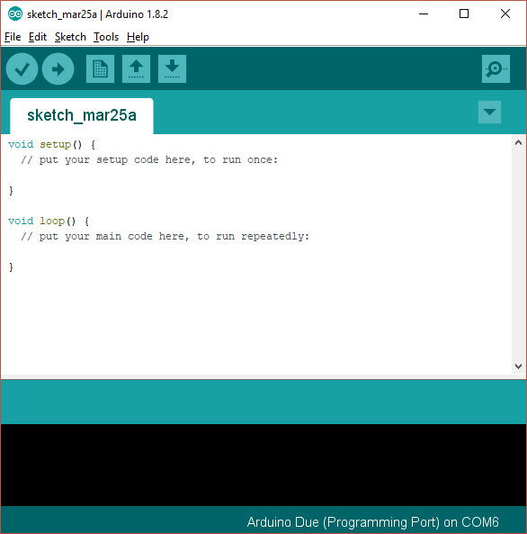

This is showing you a new, blank program. Arduino programs are called “sketches”.

# Add Support for the Arduino Nano Every Board

As shipped the Arduino IDE can build code for some of the processor types used in the Arduino range, but not for the Arduino “Nano Every” used in this project. A simple download will add the Due:

1. Open the Arduino IDE
2. Click “Tools|Board|Boards manager” on the menu
3. Scroll down to the entry for “Arduino Mega AVR boards by Arduino” and click “install”
4. Your screen should now look something like this:

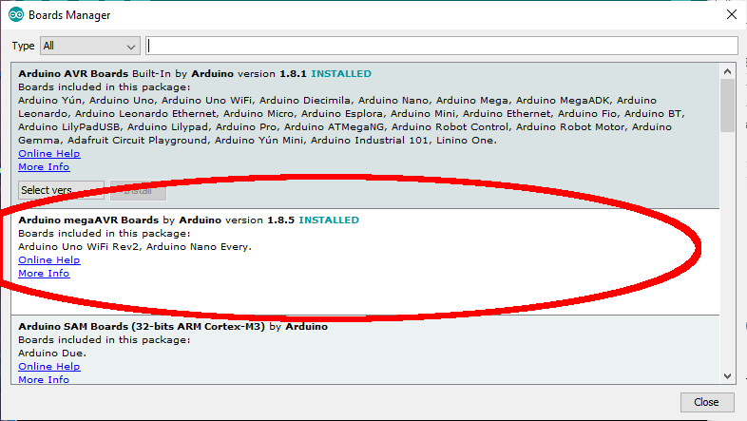

# Install Libraries into the Arduino IDE

The next step is to install a library into the Arduino library set. This will provide access to the code that we have used as part of the Ganymede build.

The Arduino system loads libraries into a folder it created on your computer; usually that folder is installed into the “documents” folder called “Arduino\libraries”. On my computer that folder is “C:\Users\loz barker\Documents\Arduino\libraries”. Use windows explorer to find that folder so you know where it is.

The required library is to control the touchscreen display: “ITEADLIB_Arduino_Nextion”. It has to be installed manually.

## ITEADLIB_Arduino_Nextion

This needs to be installed using a similar process:

1. Visit the repository on github: <https://github.com/itead/ITEADLIB_Arduino_Nextion>
2. Click “clone or download” then “download zip”
3. Store the zip file on your PC for example in the “downloads” folder
4. Open the zip file and extract all files. You will now have a folder “ITEADLIB_Arduino_Nextion-master” which will hold one folder also called “ITEADLIB_Arduino_Nextion-master”
5. Rename the second folder “ITEADLIB_Arduino_Nextion” (remove the “-master” part)
6. Copy that whole folder to your “documents\arduino\libraries” folder
7. (This is the library published by the display manufacturer. Be aware there is some foul language in the "html" folder - delete the entire "html" folder if you do not want that)
8. Your “documents\arduino\libraries” folder should now have that library:
9. 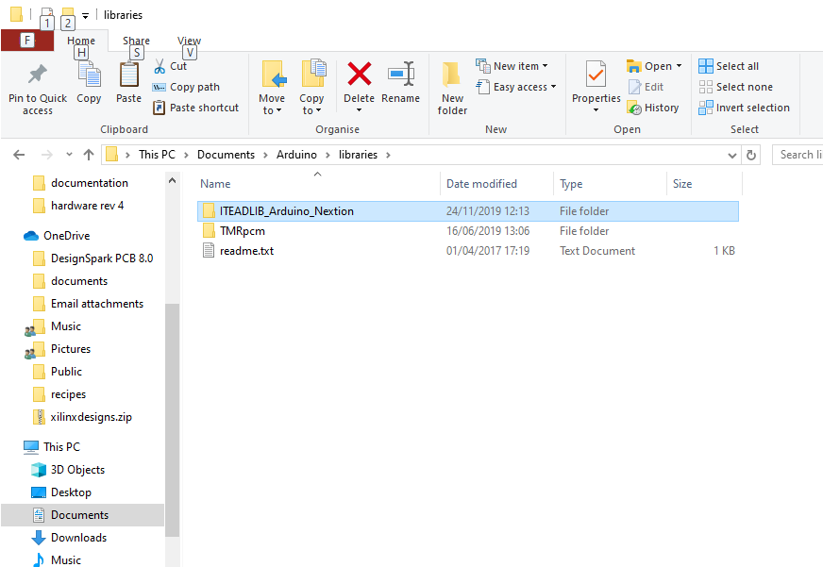

The ITEADLIB folder needs to be patched in the next phase!

# Download the Log VSWR Bridge Software Repository

1. Visit the repository on github: <https://github.com/laurencebarker/Log-VSWR-Bridge>
2. Click “clone or download” then “download zip”
3. Store the zip file on your PC for example in the “downloads” folder
4. Open the zip file and extract to your PC; for example into a folder “projects” in “documents”
5. There will be a folder called “Log-VSWR-Bridge-main” in your “projects” folder and its contents will look something like:

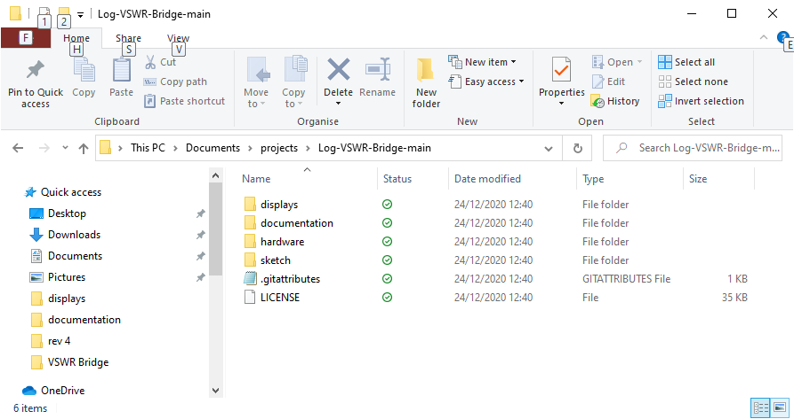

There are several folders:

|  |  |
| --- | --- |
| Displays | Bitmap backgrounds for the displays and the Nextion display editor file  Code to patch the Nextion library |
| Documentation | This installation guide and some calculator spreadsheets |
| Hardware | Schematics for the hardware (incomplete) |
| Sketch | The Arduino program for the controller. |

## Patch the ITEADLIB Library

Four files (plus a readme file) need to be copied from the Ganymede repository to the ITEADLIB folder in the Arduino libraries.

1. Open the folder “displays\arduino_library_update”
2. It will have files as follows:

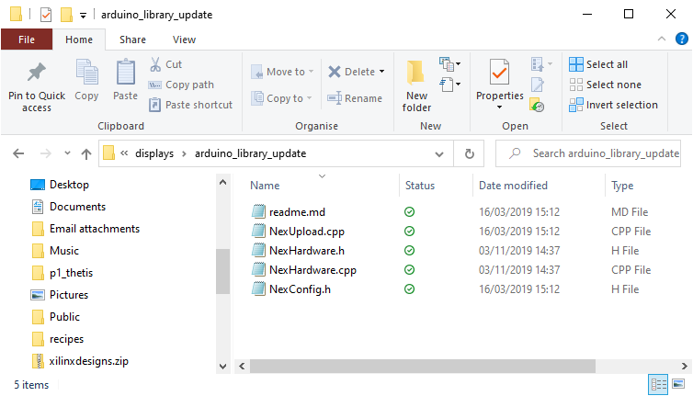

1. Select then copy those files
2. Navigate to your folder "documents\arduino\libraries\ITEADLIB_Arduino_Nextion"
3. Paste the 5 files there. Make sure you select “replace the files in the destination”

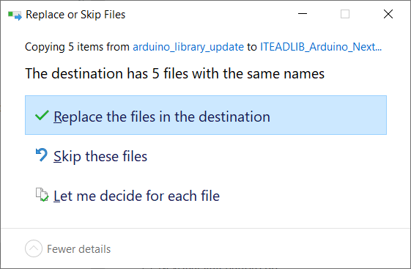

1. 4 existing files will be replaced and the readme file will be added.

## Build the code

To open the log VSWR bridge software sketch:

1. Run the Arduino IDE
2. Use the "File|Open..." menu command
3. Navigate to " Log_VSWR_sketch.ino" in folder " E:\users\laure\OneDrive\documents\projects\Log-VSWR-Bridge-main\sketch\Log_VSWR_sketch" and click "open"
4. you should now see the files listed in tabs above the editor window

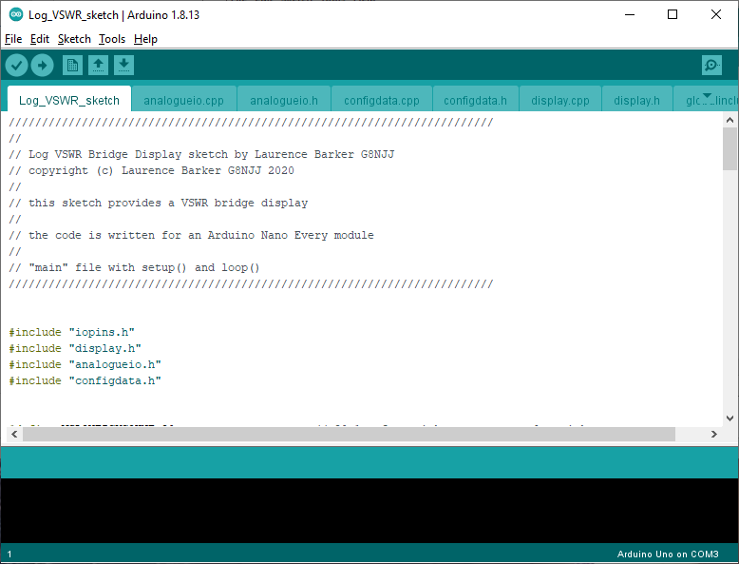

You now need to tell the IDE what kind of board it is compiling for, and which serial port to use to connect to it.

1. Connect a USB cable between the Arduino programming port (next to the black power connector) and your PC.
2. It may be necessary to install device drivers at this point – follow any instructions.
3. Click "board" on the "tools" menu and select "Arduino Nano Every” from the list
4. Click “registers emulation” on the “tools” menu and select “none (ATMEGA 4809)”
5. Click “port” on the “tools” menu and choose the Arduino COM port listed (mine is COM4)
6. Click "Verify/compile" on the "sketch" menu to compile
7. (A message “compiling sketch…” will appear. This will take around a minute and should result in a message saying the % of program space used)

Finally you need to upload the code to your Arduino:

* Click "Upload" on the "sketch" menu to upload to the Arduino
* A simple progress bar will show in the bottom window of the IDE, “uploading”
* When it has successfully finished the last message will be “done uploading”
* (A warning “avrdude: jtagmkII_initialize(): Cannot locate "flash" and "boot" memories in description” can be ignored)

Your Arduino should now be executing the VSWR Bridge code!

## Programming the Nextion Display

The Nextion display needs to be programmed with the file “logbridge_32 display.tft”. This will be in the “displays” folder. The simplest way is as follows:

1. Use windows explorer to copy the file to a micro SD card
2. Turn off the protection board
3. Insert the SD card into the socket on the display
4. Turn on the protection board
5. The display will recognise the SD card and copy the programming data into itself. It will give a message to say when it has finished.
6. When it has finished, remove power and remove the SD card.